**Final Project**

**Reporting and Analysis**

**Course: ITMD – 526 Data Warehousing**

**Project Developers**

1. **Cristina Quiroga Valcarcel**
2. **Joris Ekpangbo**
3. **Manikandan Ganesh**
4. **Saahil Sofat**
5. **Shushmitha Anthay Suthakakaran**

Report Document (Findings)

NOTE -

Prior to opening the tableau file, would have to use your localhost connection for our tables to populate.

Need to drag fact_application, dim_region and dim_department. Then all the below screenshots will be populated.

# Selectivity percentage and Yield Ratio (Per Country)

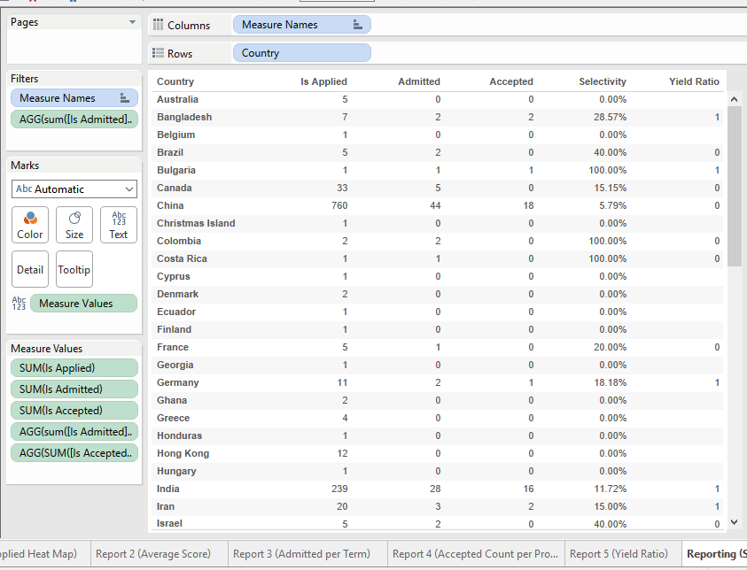



# Report 1

Heat Map representing the percentage of students from different countries around the world.

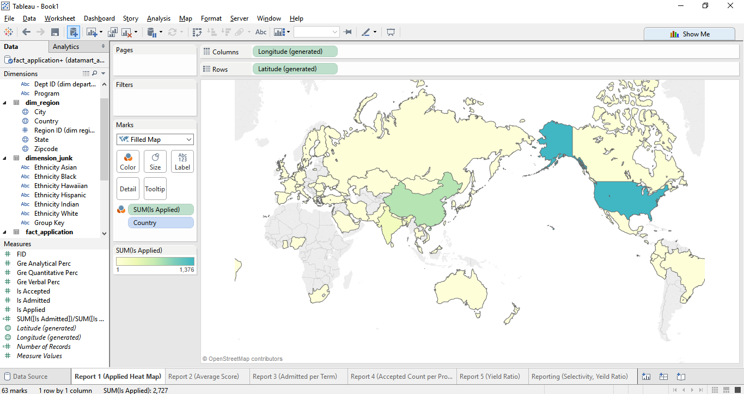

# Report 2

Average GRE scores of admitted students per department.

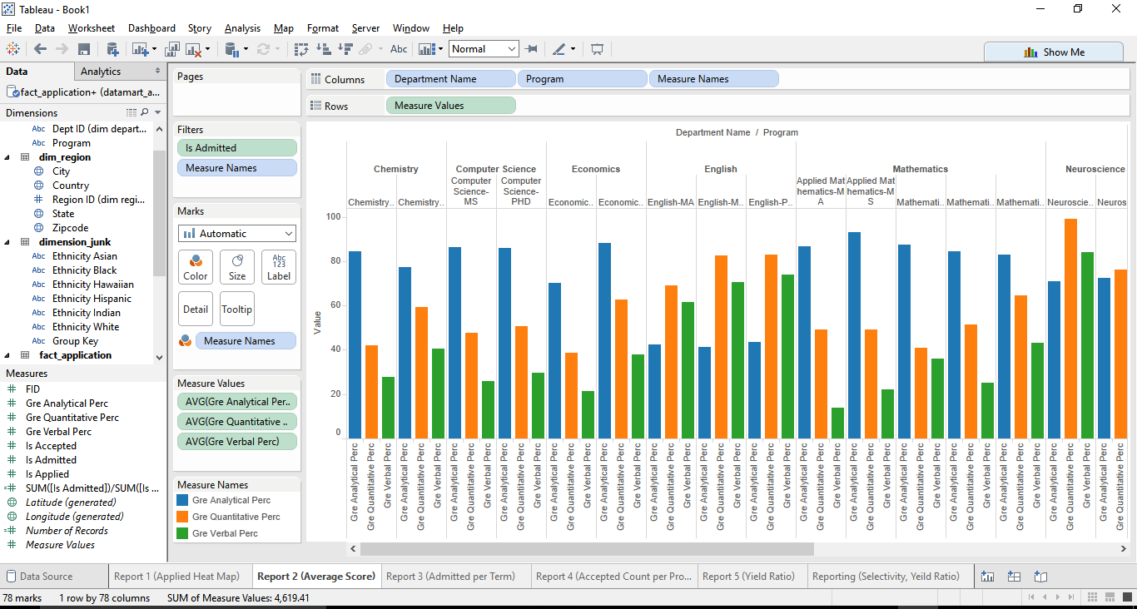

# Report 3

Count of Admitted Students per term

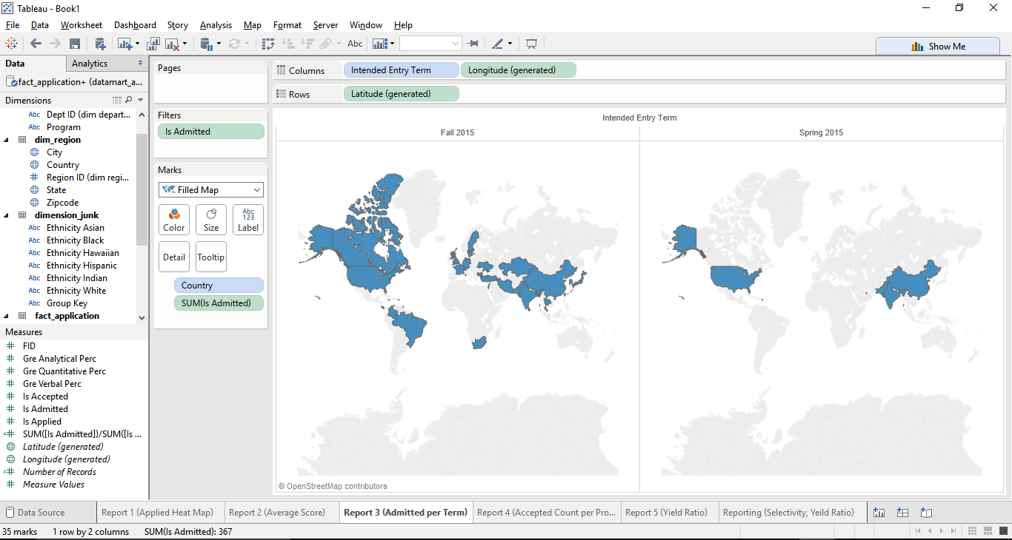

# Report 4

Number of accepted students per department.

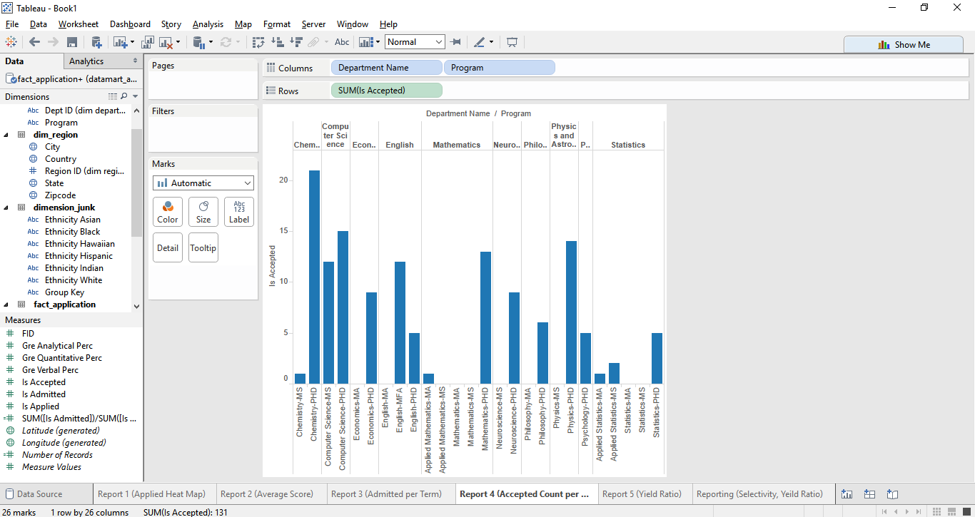

# Report 5

Yield Ratio Heat Map

